Dear JoinUs team,
We are Catchee and we would like to work with you. The name says it already (CATchy). Just like cats, we are curious and eager to explore and discover new fresh perspectives and create experiences that feel alive. When you presented your challenge to reimagine SpeedMeet, we instantly felt that this project goes hand in hand with our mission: bold, fun, human centered.
Our mission as an agency is simple: We create bold, human centered designs from websites to digital experiences that break routine and connect people in unexpected ways. We believe SpeedMeet deserves to be more than a series of conversations. You build trust and belonging, while we bring courage, creativity, and a touch of playfulness to the table. Plus, we are a fun team to work with!
Think of it like this: It can be a more interactive experience that sparks curiosity by blending bold design with humor and playful twists. This assures that every young person walks away not only with social contacts, but also with the confident thought of “Hey this was actually fun, I can do this again”.
Instead of focusing only on design, we focus on creating experiences that truly last. Every idea is explored, tested, and refined until it engages people in a real way. That’s why our work doesn’t just look appealing, it leaves an impact and stays memorable.
Let’s make SpeedMeet not just a tool, but an adventure in connection.
With curiosity and courage,
The Catchee Team
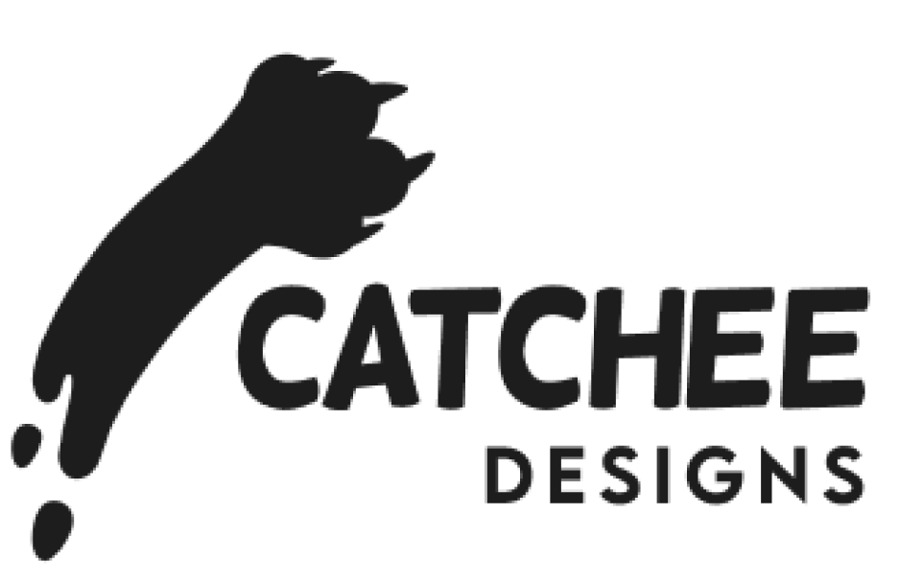

Desca Creative
Hi Desca! We're Catchee Designs, a team of diverse Media Designers excited to work with you. After (and during) your pitch we felt very inspired to create very fun stuff. We resonated a lot with your story about shitty days, going on YouTube and watching our favorite creators to feel better. We also really like the idea of funny, stupid, inside jokes to deepen your audience connection and attract new viewers.
Our team has a big interest in social media, gaming and designing. We have a big range of skills like: creating cool games, 3D environments, we have illustrators who love to make art (from dreamy to funny, realistic to simplistic), a social media strategist, concept designer and musician. Our strength lies in connecting, listening to what you need and transform it into something awesome. You will also be provided with examples of our best work below.
We especially got excited by the idea of gamifying your streams and are looking forward to make them interactive and fun. We’re already envisioning emotes and overlays around Calcifer and Todo and want to give them an important role in your branding. We’d also like to explore new ways to make your behind-the-scenes content engaging.
Above all we’d love to learn from each other and build something unique, fun and unforgettable for you and your community.
With curiosity and courage,
The Catchee Team

